如何获取公司名称发票
HOW TO GET THE ELECTRONIC RECEIPT WITH A COMPANY TITLE
- 网上缴费
ONLINE PAYMENT
如果是通过网上缴费方式，在缴费时请按照如下步骤操作：
If you make the online payment, please follow the following steps.
- 使用微信、支付宝或信用卡在线支付（http://apply.sjtu.edu.cn）用学号（HXXXXXXXXXX）(学号请参见附件的录取通知书) 登录，密码是护照号码后六位数。
To pay online visa WeChat, Alipay or credit card, please login the webhttp://apply.sjtu.edu.cn with your student ID （HXXXXXXXXXX）. The password is the last six numbers of your passport number.
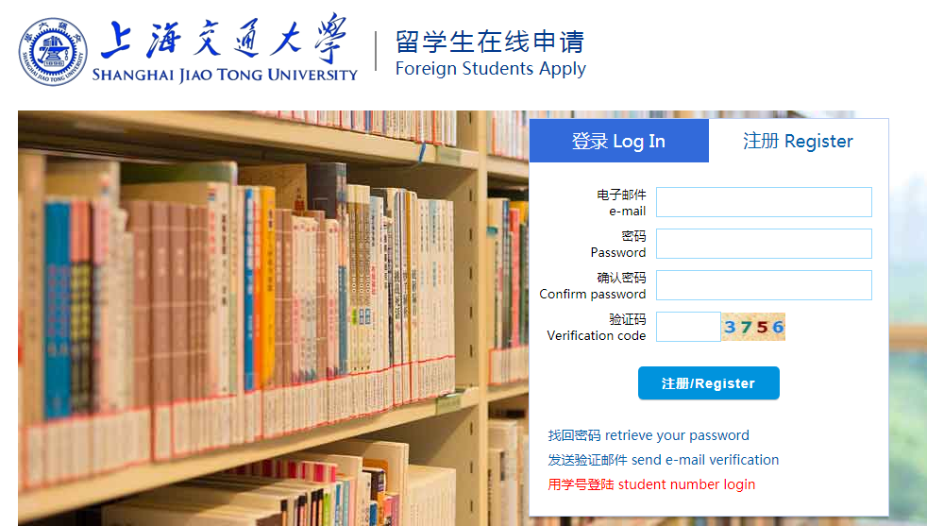
- 请选择“payment”
Please choose the “Payment”
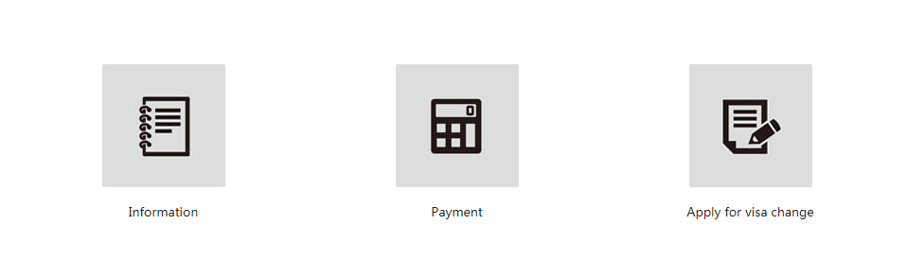
- 在缴费页面最下面，选择“是”，然后进行填写相关信息。
Please go to the bottom of the page and choose”是”，and then fill the relevant information.

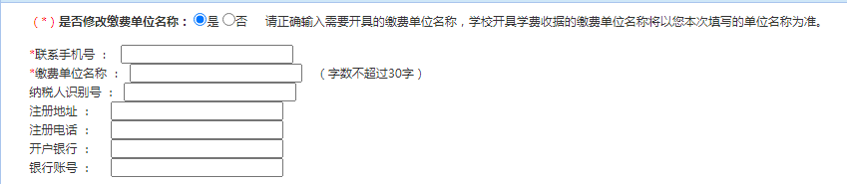
- 在你缴费成功之后，请退出重新登录，电子发票即可生成，如下图。
After you pay the fees sucessfully, please relogin the website again. And you will get the invoice when you choose the button “ INVOICE”.
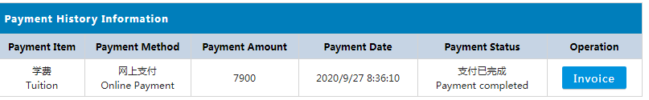

- 银行汇款
BANK REMITTANCE
如果通过此方式缴费并需要公司抬头，请再付款前发邮件至clpvisa@sjtu.edu.cn
If you transfer the fees and need the company name, please email: clpvisa@sjtu.edu.cn before the payment.
两周后按照如下操作获取发票。
After two weeks, you can get the receipt as the following

第一步：打开 www.jdcw.sjtu.edu.cn
STEP 1: Open the webside www.jdcw.sjtu.edu.cn
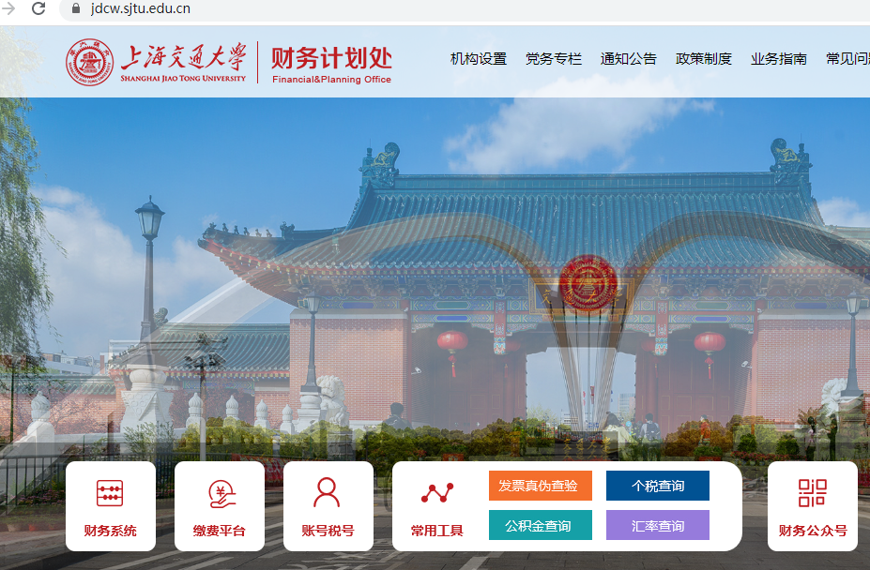

第二步: 点击右下方 “缴费平台”。
STEP 2: CLICK THE SECOND BUTTON OF “缴费平台”
第三步：输入 10 位号码的学号，类似 20XXXXXXXX。
STEP 3: Input your student number, e.g. 20XXXXXXX.
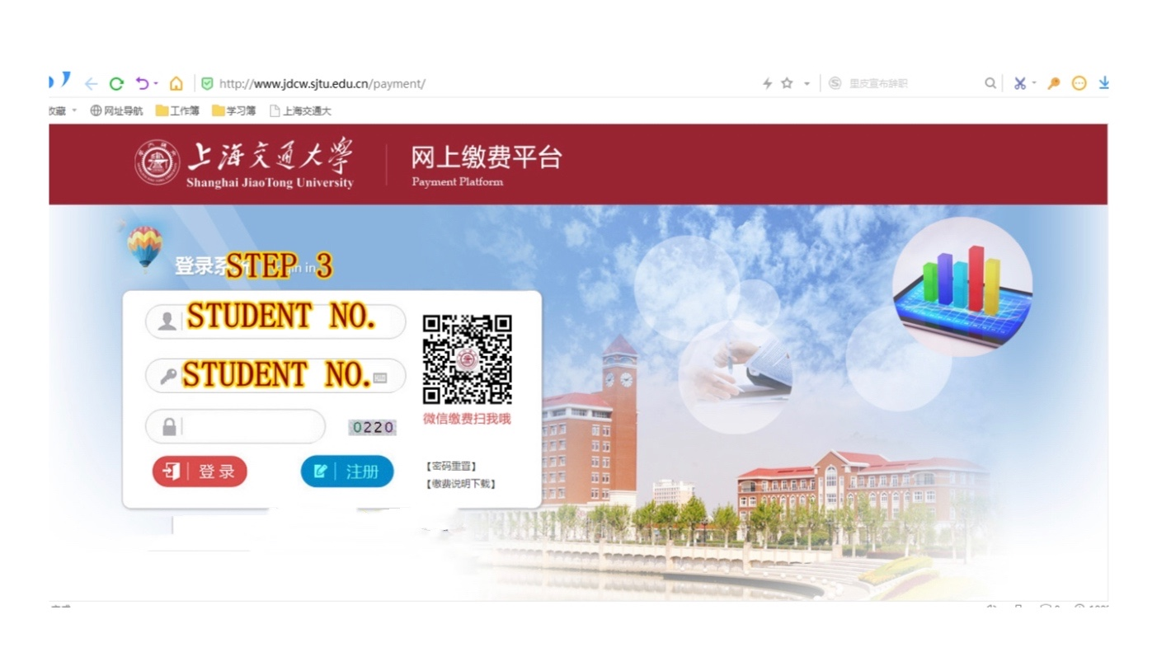
20XXXXXXX

第四步: 进入后核对名字，点击电子票据，查看电子票据。
STEP 4: After getting in, please check your name and click the button of “ELETRONIC RECEIPT”